Personality traits
Institutional affiliation
Name of lecturer
Name of student
Submission date

Introduction
Personality refers to characteristic differences that might exist in people that show a proper way of thinking. It is a concern with how human beings are classified according to their psychological characteristics. It can be said to be the qualities that make human beings alike, and those common features distinguish human beings from animals. Therefore, personality is not determined by a single factor but a combination of psychological, physical hereditary and biological factors. As such personality is influenced by factors like the brain, physical characteristics like height weight, skin colour, and beauty. The physical characteristics of an individual influence how a person interacts with others. Other factors include social experience, culture and religion, and heredity. All these factors combine to form traits that describe an individual (Buss & Plomin 2014).
According to my personality self-portrait, my strong characteristics or trait are self-confident, idiosyncratic, and mercurial. These traits have a score of 18 in my personality portrait graph. My lowest traits are vigilant, solitary, leisurely, serious, and sensitivity. My highest score in these traits is 14. Most of the tomes I show very little vigilance when serious issues are brought on the table. This decreases my seriousness when handling crucial matters. This made most of my friends not to trust my approaches to matters. Though this is the case, I am always confident when applying my principles. Anything that I am involved still succeeds. My behaviours are ever changing, and thus one cannot predict my moods and idiosyncratic.

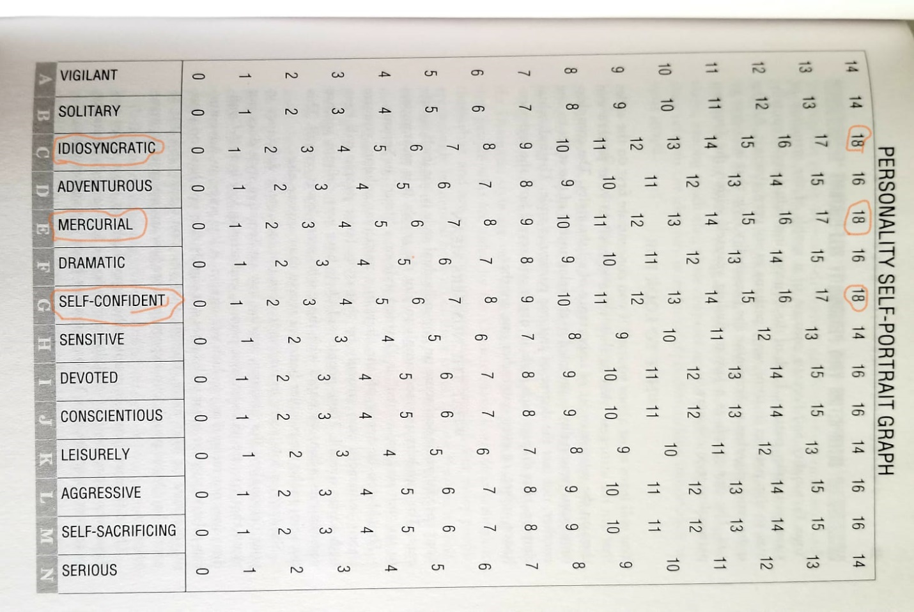
The personality portrait description of my traits can be described as one of the most appropriate ways of determining characteristics of an individual. Through personality portrait description, one understands him or herself better. This is because an individual relates and estimate his or personal behaviour by assigning a personality trait. Also, one can identify his or her strengths and give priorities on the strengths. If an individual has a weak personality, he or she can work through his or her experiences to determine what caused the change in personality. This helps the individual to have positive thinking towards life and develop a better personality. This makes personality portrait more relevant when evaluating the personality of an individual.
The personality portrait assessment was accurate and thus relevant in the evaluation of personality behaviour of individuals. This is because, with the given outcomes of the evaluation, one can understand his or her traits better even without considering personal experiences. This makes the assessment valid and reliable. Also, it gives standards upon an attribute is measured and thus assign a coefficient to it. This simplifies trait determination. As such, personality assessment portrait is simple and can be done by any literate individual. Portrait assessment also allows an individual to choose an inventory that aid in decision making. This helps the person conducting the assessment to develop a test which validates the available data.
When conducting my personality test, most of my decisions are based on experiences and current personal behaviour that has shaped by current personality. Scholars argue that experience shape and individual and thus, my personality have been changing over and over. During my younger years, I was characterized by vigilance, sensitivity and seriousness in all what is tackled. Together with self-confidence, a more active personality described the person I was during these years. These traits influenced my response to issues pertaining to education and lifestyle. I was also vigilant on all occasion, serious and always independent when tackling problems. This has changed over time to be a person who does not care and dependent on others to combat situations. This has affected my opinions, feeling and way of thinking. As such, I can attribute these changes to three main factors that might have influenced my personality. These factors are mental illness, physical disorders and substance abuse. During my early adolescence, I was involved in an accident that left numerous scars on my body. This posed a challenge on me and personal appearance. The differentiated me started ignoring what is essential and taking chances to see what will happen if I don't take the indented action. As a result, I become more and more scared about my future and thus become depressed more and more. This brought a mental disorder. To reduce the stress and depression, I turned to substance abuse that has kept me out of my original personality and thus I the change of personality to these factors (Oldham & Morris 1995).
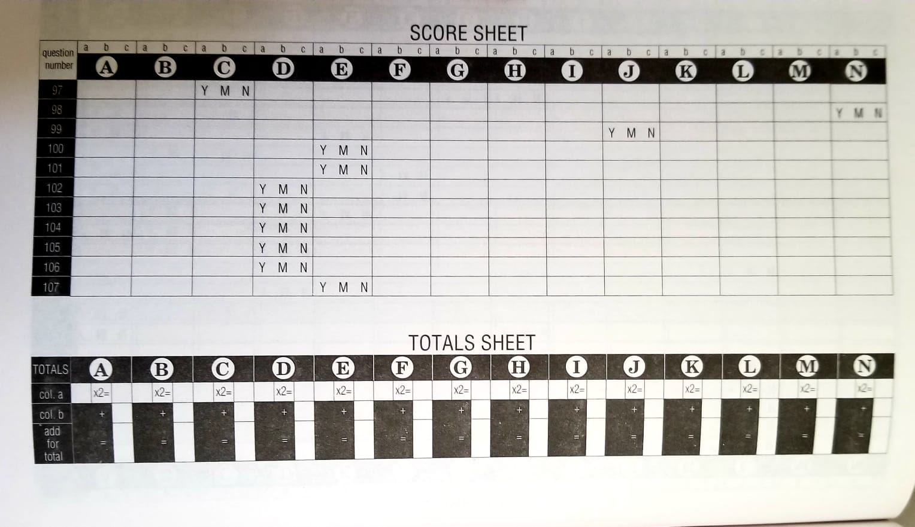
Self-confidence, solitary and idiosyncratic traits show a more dramatic, erratic and emotional pathology. Self-confidence and solitary traits have influenced me to work more independently and thus neglecting others. This has led to my disregard to others, and therefore most of the times I do violate their rights. This has been influenced most by my changing behaviours and moods that are not predictable. I most cases, I don't relate well with others, and thus I always have an unstable relationship.
Due to continued separation from the others, dramatic, erratic and emotional pathology has its strengths and weakness. A self-confident person can work effectively under minimal without supervision. This makes the person effective and accurate when working alone. Also, he or she has better concentrations and thus can work for long hours. The negative side of this pathology is that the person is unable to work in a group, and therefore he or she seeks attention from the other group members. This may lead to delayed accomplishments of the task. The person is also moody, non-tolerant to changes. The person also takes criticism more personal and thus shows anti-social behaviour.
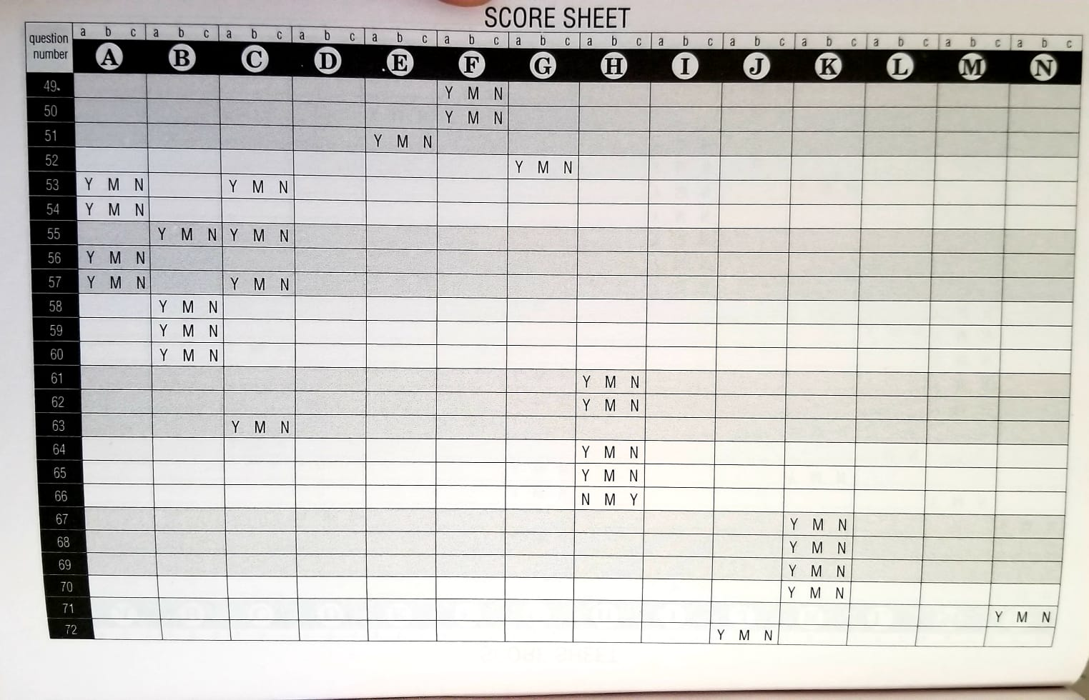
Conclusion
In an assessment of personality traits, an individual has to decide on what should be included in the assessment. More thought decisions led to the formulation of valid and reliable data that can be used in the personality assessment. This makes the outcomes of the assessment more accurate and dependable.

Reference
Buss, A. H., & Plomin, R. (2014). Temperament (PLE: Emotion): Early developing personality traits. Psychology Press.
Oldham, J. M., & Morris, L. B. (1995). The personality self-portrait. New York, NY: Bantam.

